**Day 8**  
**Friend Function, Pure Virtual, FileHandling, Templates**

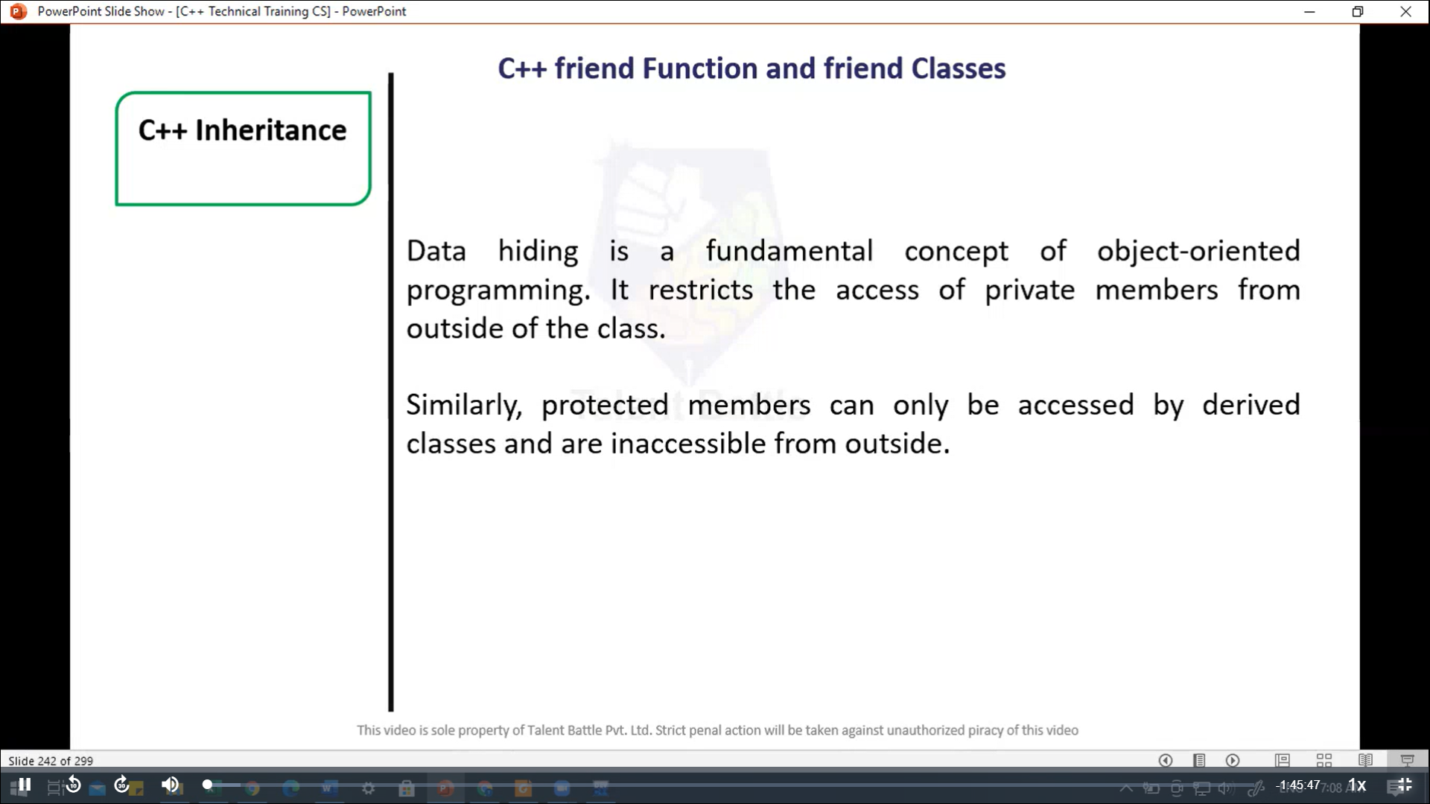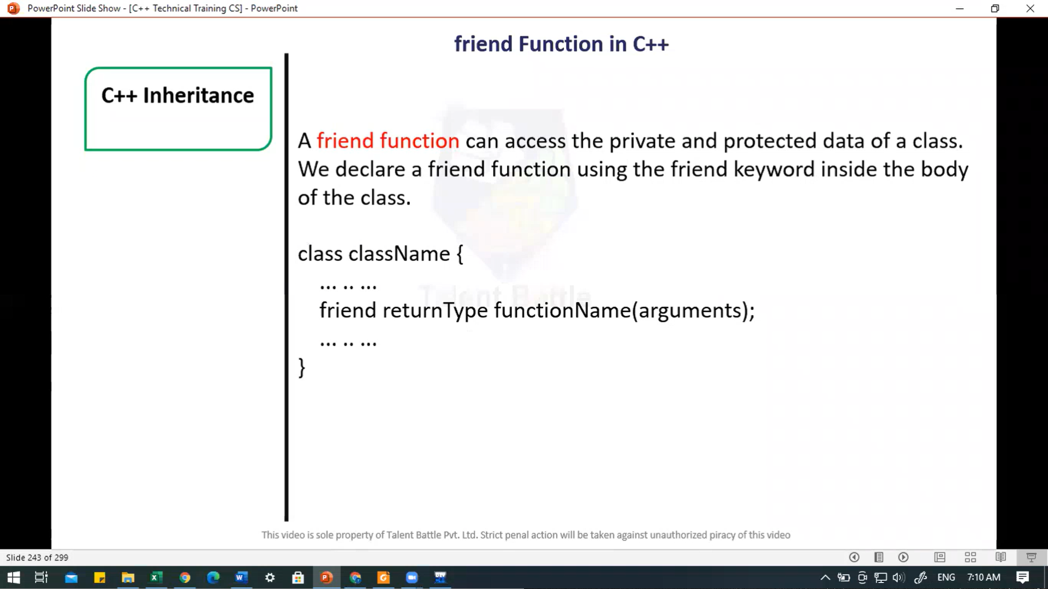

// C++ program to demonstrate the working of friend function

#include<iostream>

using namespace ***std***;

*class* Distance {

  private***:***

    int meter;

    // friend function

    friend int *addFive*(Distance);

  public***:***

*Distance*()***:*** *meter*(0){}

};

// freind function definition

int *addFive*(Distance ***d***){

  // Accessing private members from the friend function

  d***.***meter += 5;

  return d***.***meter;

}

int *main*(){

  Distance D;

  cout ***<<*** "Distance: " ***<<*** *addFive*(D);

  return 0;

}

/*

Distance: 5

--------------------------------

Process exited after 0.1592 seconds with return value 0

Press any key to continue . . .

*/

//===============================================

// Add members of two different classes using friend functions

#include<iostream>

using namespace ***std***;

// forward declaration

*class* ClassB;

*class* ClassA{

  public***:***

    // constructor to initialize numA to 12

*ClassA*()***:*** numA(12){}

  private***:***

    int numA;

    // friend funciton declaration

    friend int *add*(ClassA***,*** ClassB);

};

*class* ClassB{

  public***:***

    // constructor to initialize  numB to 1

*ClassB*()***:*** numB(1){}

  private***:***

    int numB;

    // friend funciton declaration

    friend int *add*(ClassA***,*** ClassB);

};

// access members of both classes

int *add*(ClassA ***objectA,*** ClassB ***objectB***){

  return (***objectA.***numA + ***objectB.***numB);

}

int *main*(){

  ClassA objectA;

  ClassB objectB;

  cout *<<* "Sum: " *<<* *add*(objectA***,*** objectB);

  return 0;

}

/*

Sum: 13

--------------------------------

Process exited after 0.1271 seconds with return value 0

Press any key to continue . . .

*/

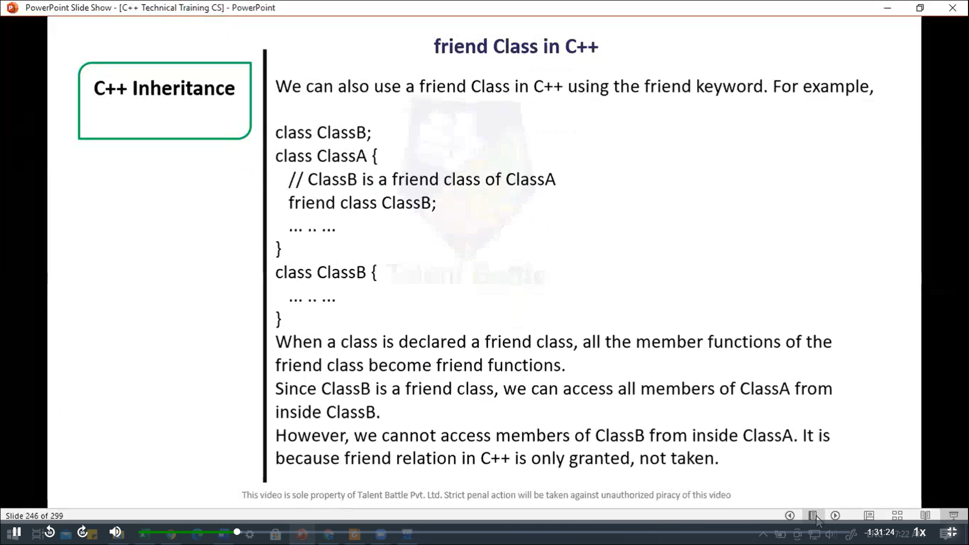

//===================================================

// C++ program to demonstrate the working of friend class

#include <iostream>

using namespace ***std***;

// forward declaration

*class* ClassB;

*class* ClassA{

  private***:***

    int numA;

    // friend class declaration

    friend *class* ClassB;

  public***:***

    // constructor to initialize numA to 12

*ClassA*()***:*** numA(12){}

};

*class* ClassB{

  private***:***

    int numB;

  public***:***

    // constructor to initialize numB to 1

*ClassB*()***:*** numB(1){}

    // memer friend to add numA

    // from ClassA and numB from ClassB

    int *add*(){

      ClassA objectA;

      return objectA***.***numA + numB;

    }

};

int *main*(){

  ClassB objectB;

  cout *<<* "Sum: " *<<* objectB***.****add*();

  return 0;

}

/*

Sum: 13

--------------------------------

Process exited after 0.1059 seconds with return value 0

Press any key to continue . . .

*/

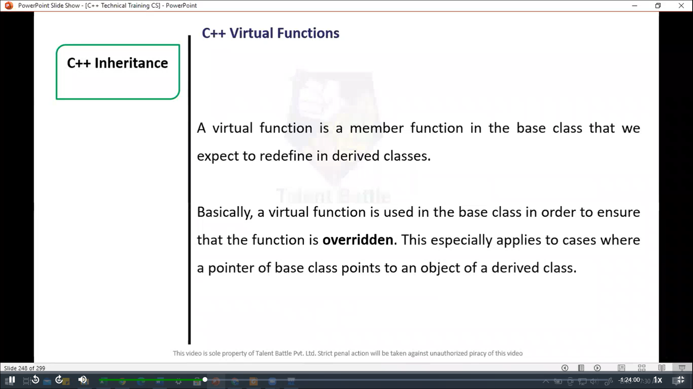

//===================================================

// C++ program to demonstrate the use of virtural functions

#include<iostream>

using namespace ***std***;

*class* Base{

  public***:***

    virtual void *print*(){

      cout *<<* "Base Function" *<<* *endl*;

    }

};

*class* Derived ***:*** public Base {

  public***:***

    void *print*(){

      cout *<<* "Derived function" *<<* *endl*;

    }

};

int *main*(){

  Derived derived1;

  // pointer of Base type that points to derived1

  Base*base1 = ***&***derived1;

  // class member funciton of Derived class

  base1 ***->*** *print*();

  return 0;

}

// Virtul funcitons are runtime polymorphism.

/*

Derived function

--------------------------------

Process exited after 0.1403 seconds with return value 0

Press any key to continue . . .

*/

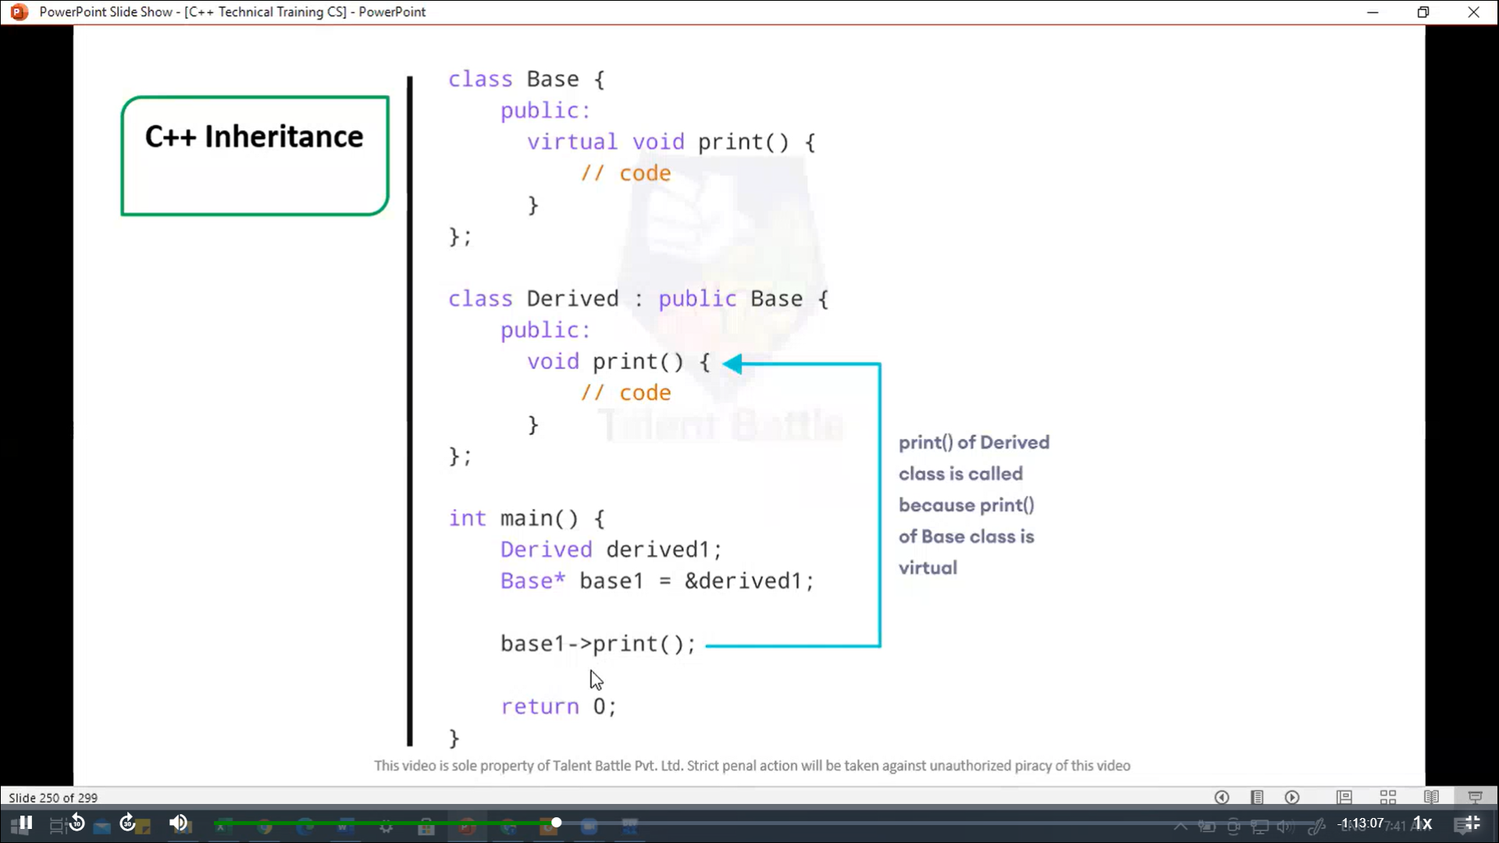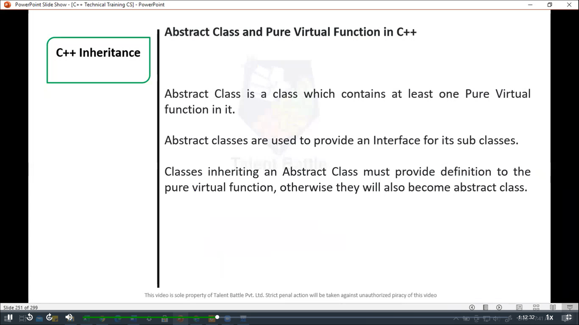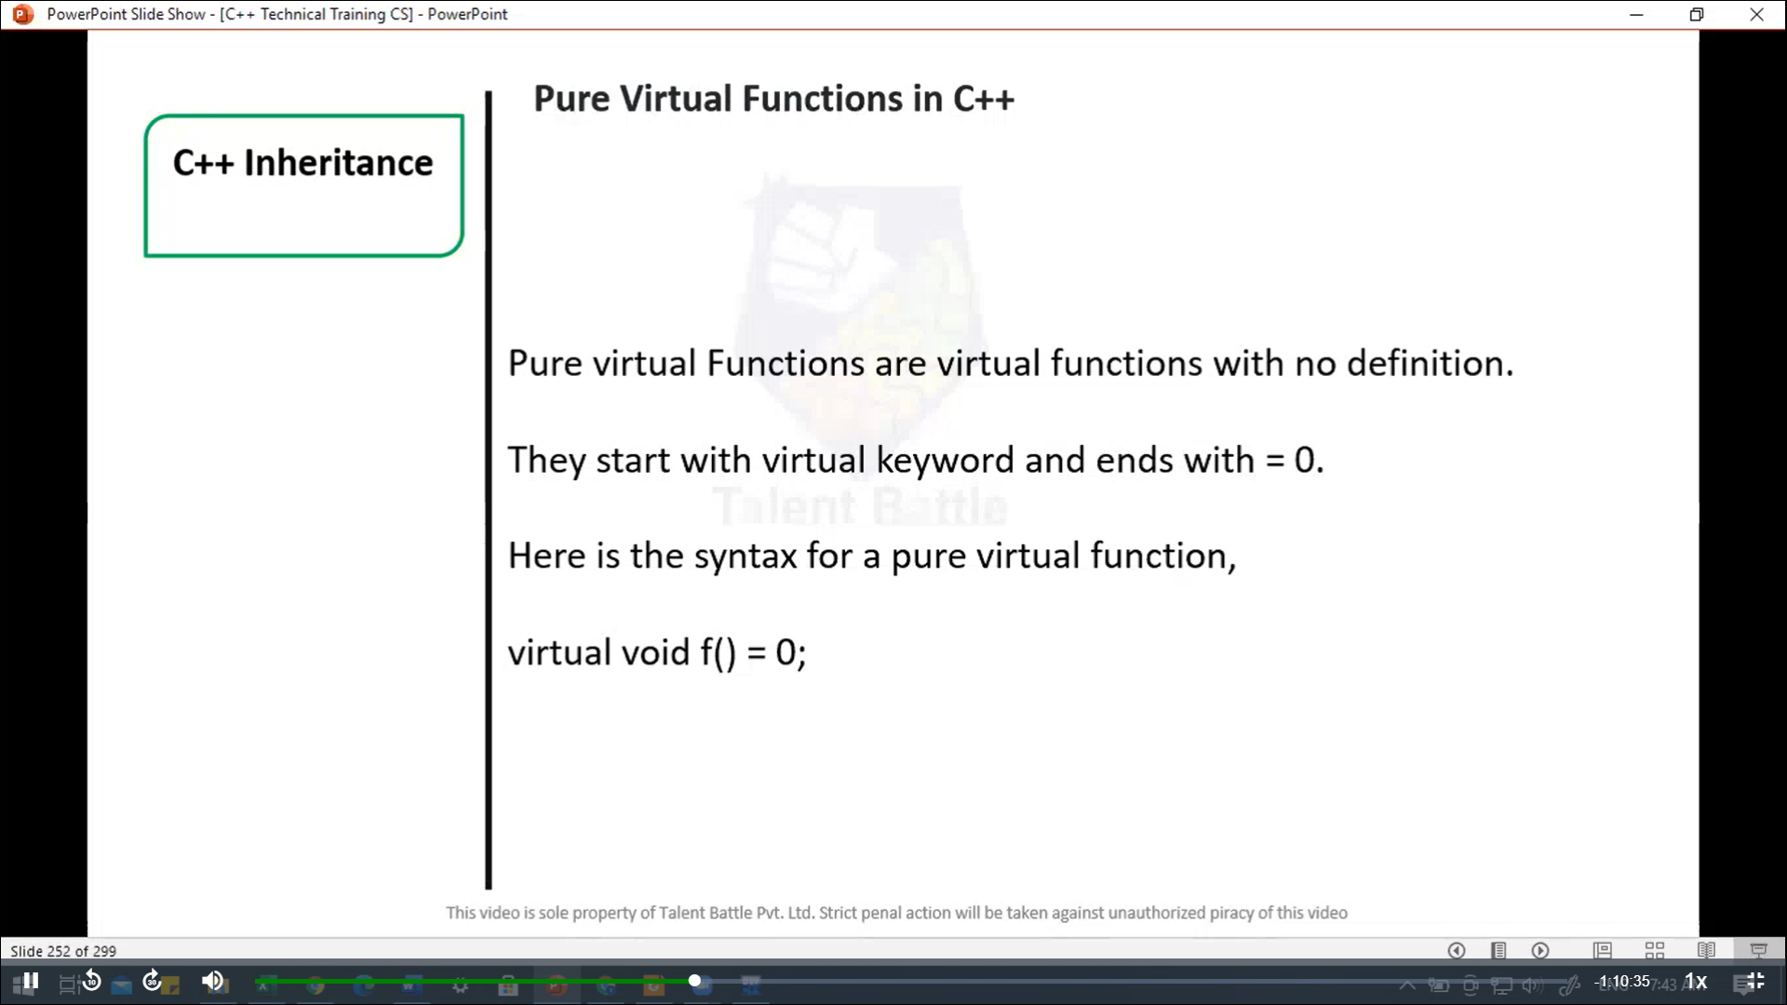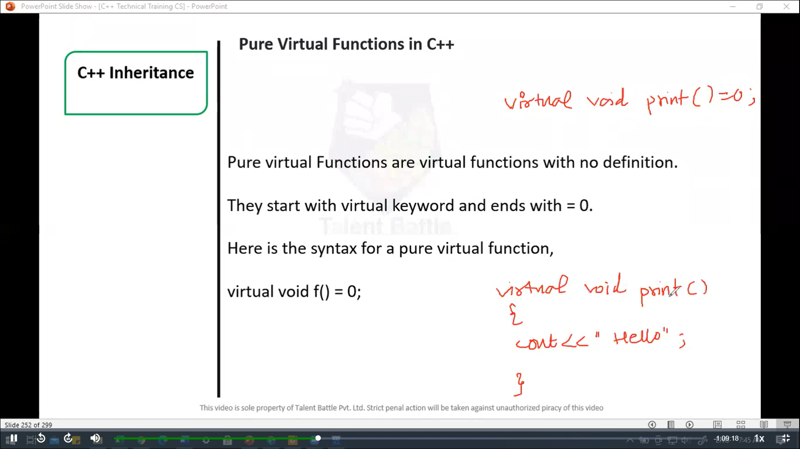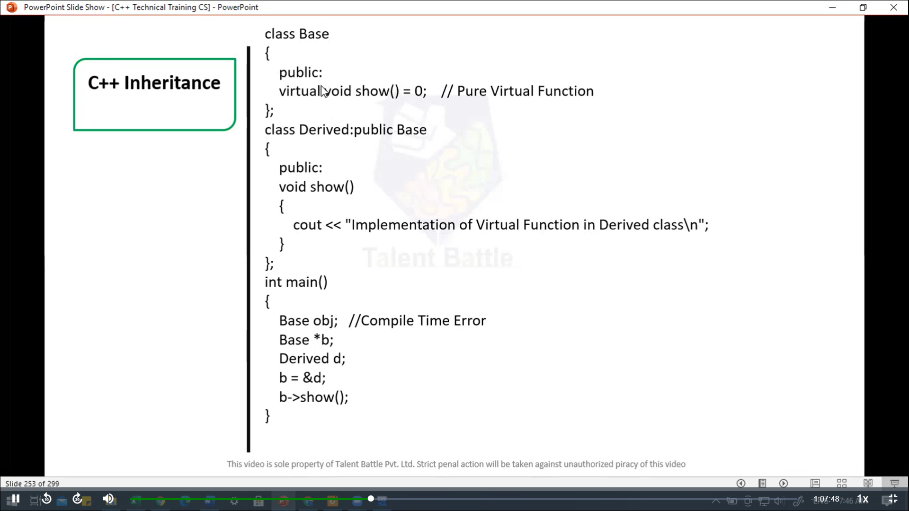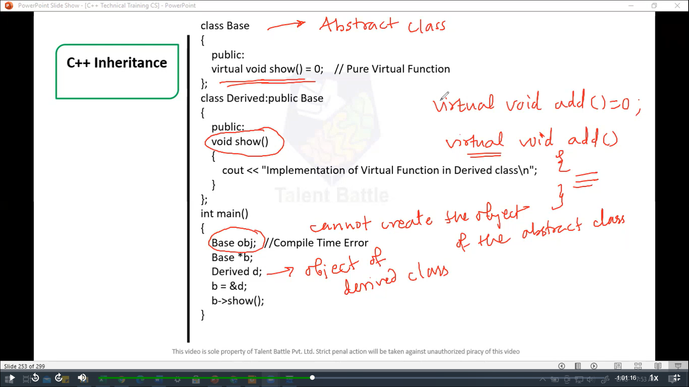

//============================================

// pure virtual function

#include<iostream>

using namespace ***std***;

*class* Base{

  public***:***

    virtual void *show*()=0; // pure virtual function

};

*class* Derived***:*** public Base{

  public***:***

    void *show*(){

      cout *<<* "Implementation of Virtual funciton in Derived class**\n**";

    }

};

int *main*(){

  //Base obj; // Compile Time Error

  Base *b;

  Derived d;

  b = ***&***d;

  b ***->****show*();

  return 0;

}

/*

Implementation of Virtual funciton in Derived class

--------------------------------

Process exited after 0.12 seconds with return value 0

Press any key to continue . . .

*/

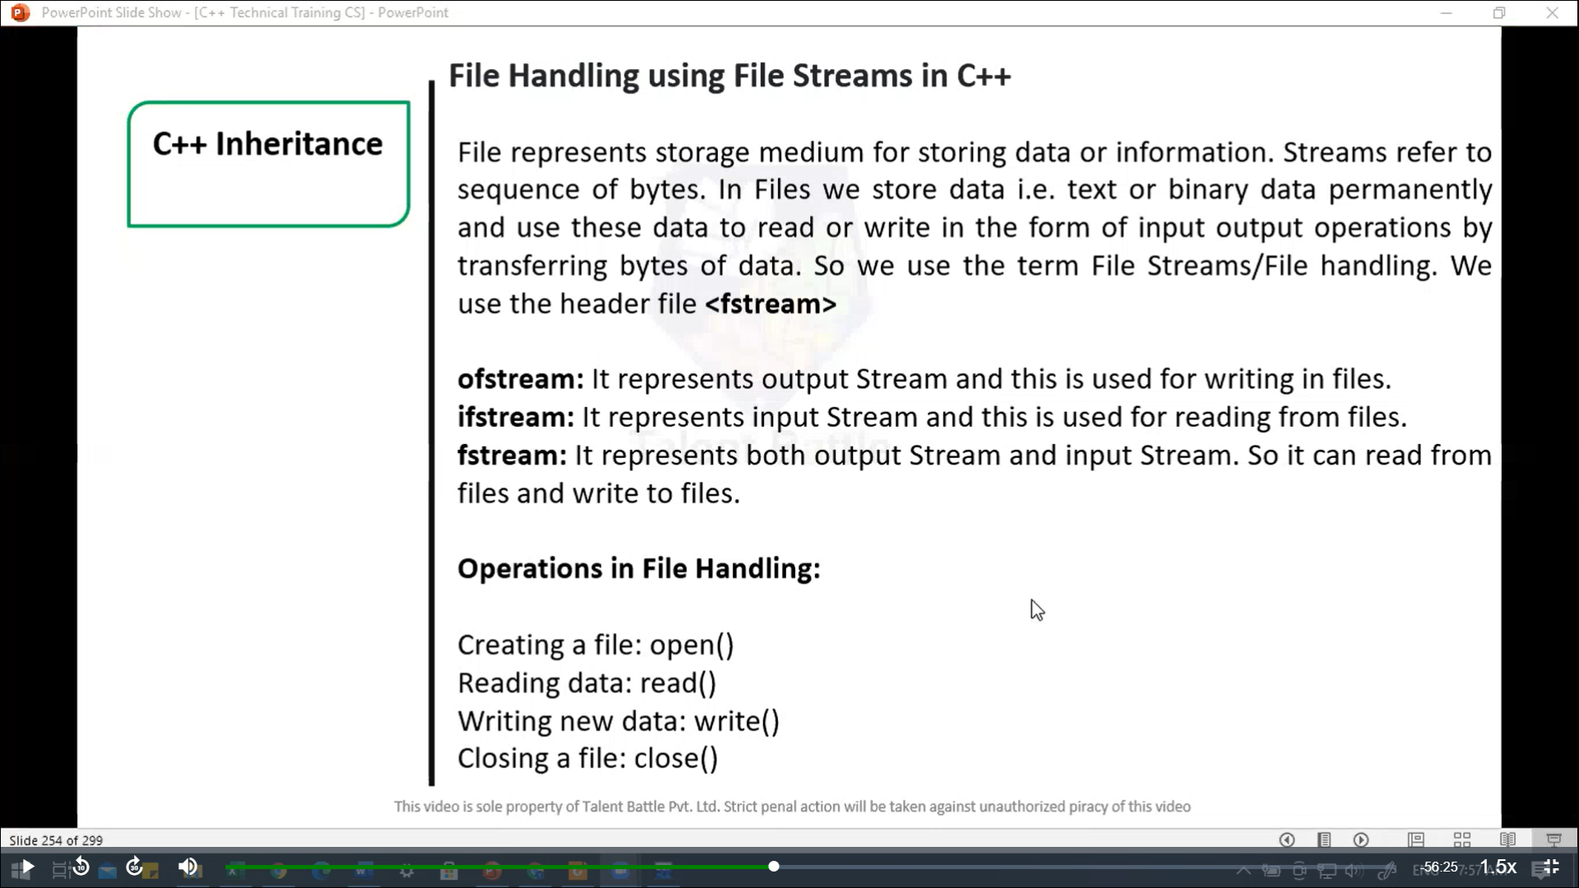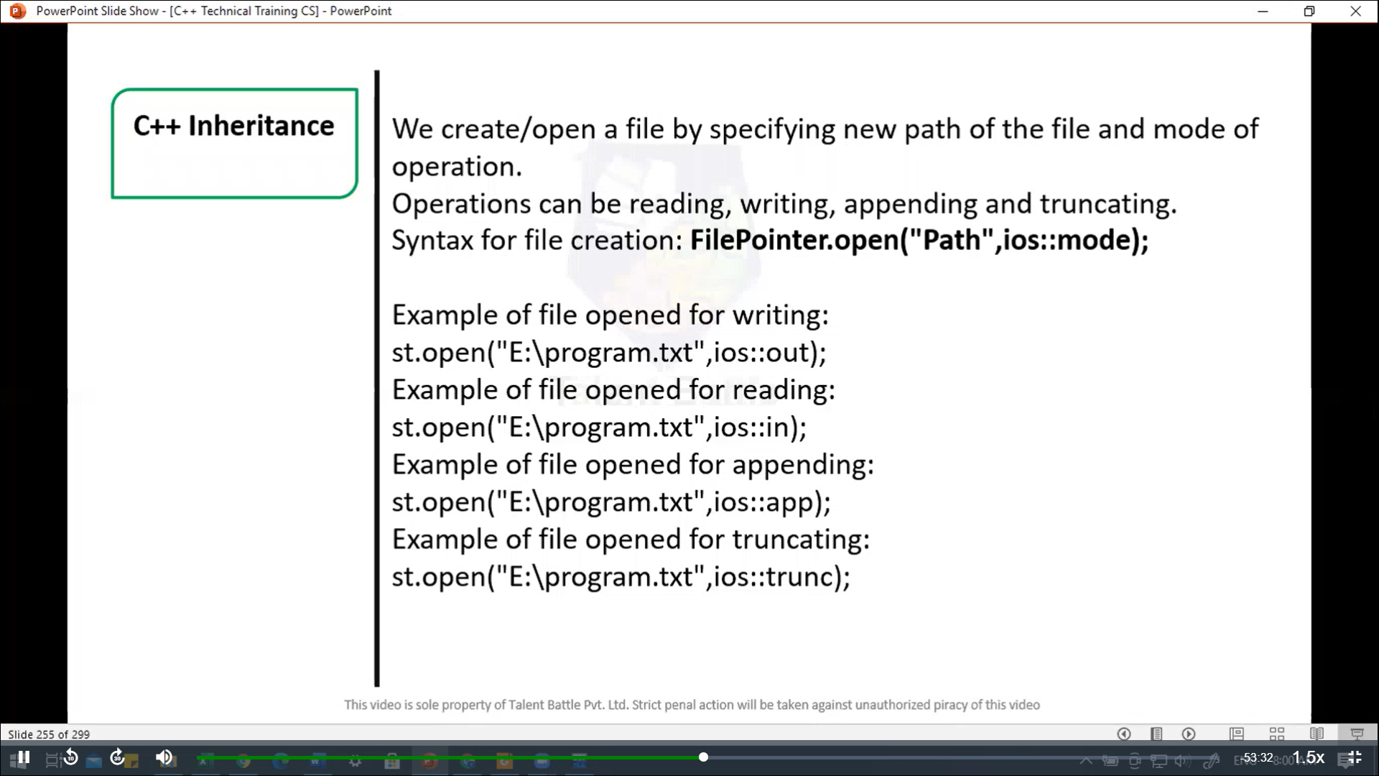

//==========================================

// file handling

#include<fstream>

#include<iostream>

using namespace ***std***;

int *main*(){

  fstream st; // step 1: creating object of fstream class

  st***.****open*("C:/Users/hp/Desktop/TCS IT/C++ language/Day8/program.txt"***,*** ios***::***out); // Step 2: create new file

  if(*!*st) // step 3: checking whether file exist

  {

    cout *<<* "File creation failed";

  } else {

    cout *<<* "New file created";

    st***.****close*(); // step 4: Closing file

  }

  return 0;

}

/*

New file created

--------------------------------

Process exited after 0.1531 seconds with return value 0

Press any key to continue . . .

*/

//===============================================

// file handling --> writing too a file

#include<iostream>

#include<fstream>

using namespace ***std***;

int *main*(){

  fstream st; // Step 1: create object of fstream class

  st***.****open*("C:/Users/hp/Desktop/TCS IT/C++ language/Day8/program.txt"***,*** ios***::***out); // Step 2: creating new file

  if(*!*st) // step 3: checking whether file exist

  {

    cout *<<* "File creation failed";

  } else {

    cout *<<* "New file created";

    st *<<* "Hello"; // step 4: writing to file

    st***.****close*(); // step 5: closing file

  }

  return 0;

}

/*

New file created

--------------------------------

Process exited after 0.01468 seconds with return value 0

Press any key to continue . . .

*/

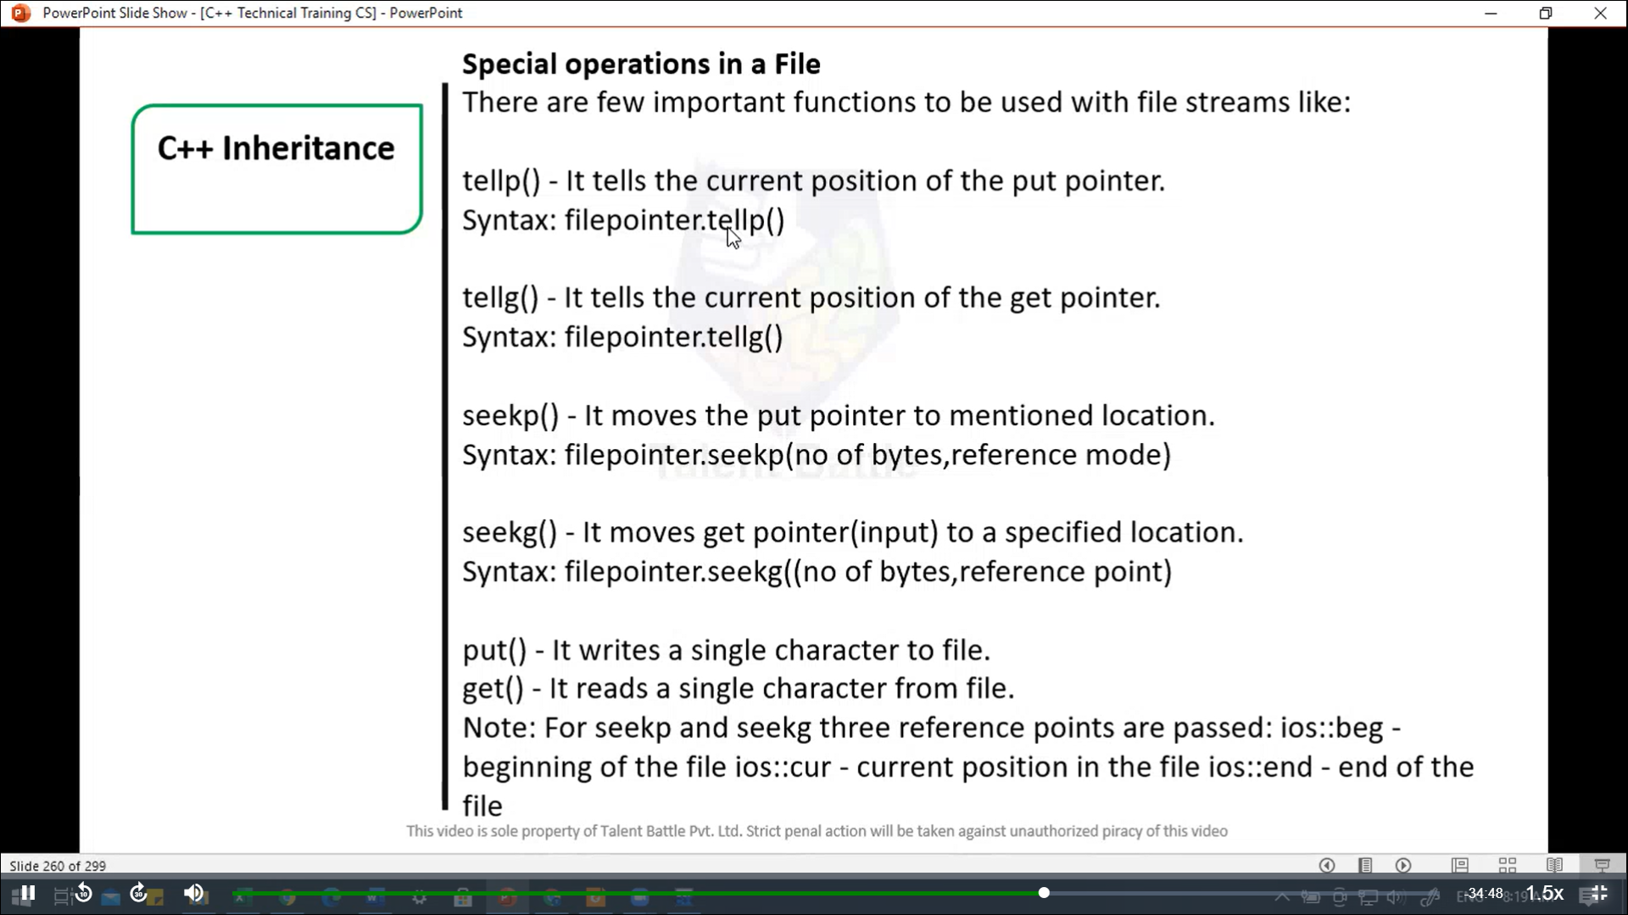

//===============================================

// file handling --> Reading from a file

/*

#include<iostream>

#include<fstream>

using namespace std;

int main(){

  fstream st; // Step 1: create object of fstream class

  st.open("C:/Users/hp/Desktop/TCS IT/C++ language/Day8/program.txt", ios::in); // Step 2: creating new file

  if(!st) // step 3: checking whether file exist

  {

    cout << "No such file";

  } else{

    char ch;

    while(!st.eof()){

      st >> ch; // step 4: Reading from file

      cout << ch; // Message Read from file

    }

    st.close(); // step 5 : closing file

  }

  return 0;

}

*/

/*

ThisisC++filee

--------------------------------

Process exited after 0.01591 seconds with return value 0

Press any key to continue . . .

*/

//==============================================

// close a file

// It is done by FilePointer.close()

#include<iostream>

#include<fstream>

using namespace ***std***;

int *main*(){

  fstream st; // step 1: creating object of fstream class

  st***.****open*("C:/Users/hp/Desktop/TCS IT/C++ language/Day8/program.txt"***,*** ios***::***out); // step 2: creating new file

  st***.****close*(); // step 3 : closing file

  return 0;

}

/*

--------------------------------

Process exited after 0.01027 seconds with return value 0

Press any key to continue . . .

*/

//====================================

#include<iostream>

#include<fstream>

using namespace ***std***;

int *main*(){

  fstream st; // creating object of fstream class

st***.****open*("C:/Users/hp/Desktop/TCS IT/C++ language/Day8/program.txt"***,*** ios***::***out); // create new file

  if(*!*st) // checking whether file exist

  {

    cout *<<* "File creation failed";

  } else {

    cout *<<* "New file created" *<<* *endl*;

    st *<<* "Hello Friends"; // writing to file

    // checking the file pointer position

    cout *<<* "File pointer position is " *<<* st***.****tellp*() *<<* *endl*;

    st***.****seekp*(-1***,*** ios***::***cur); // Go one position back from current position

    // checking the file pointer position

    cout *<<* "As per tellp file pointer position is " *<<* st***.****tellp*() *<<* *endl*;

    st***.****close*(); // closing file

  }

  st***.****open*("C:/Users/hp/Desktop/TCS IT/C++ language/Day8/program.txt"***,*** ios***::***in); // opening file in read mode

  if(*!*st) // checking whether file exist

  {

    cout *<<* "No such file";

  } else {

    char ch;

    st***.****seekg*(5***,*** ios***::***beg); // go to position 5 from beging.

    cout *<<* "As per tellg File pointer position is " *<<* st***.****tellg*() *<<* *endl*; // checking file pointer position

    cout *<<* *endl*;

    st***.****seekg*(1***,*** ios***::***cur); // Go to position 1 from beginning

    st***.****close*(); // closing file

  }

  return 0;

}

/*

New file created

File pointer position is 13

As per tellp file pointer position is 12

As per tellg File pointer position is 5

--------------------------------

Process exited after 0.1185 seconds with return value 0

Press any key to continue . . .

*/

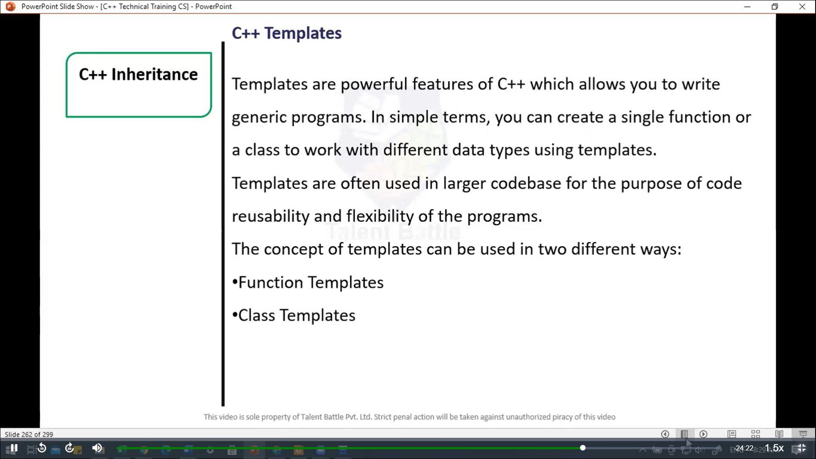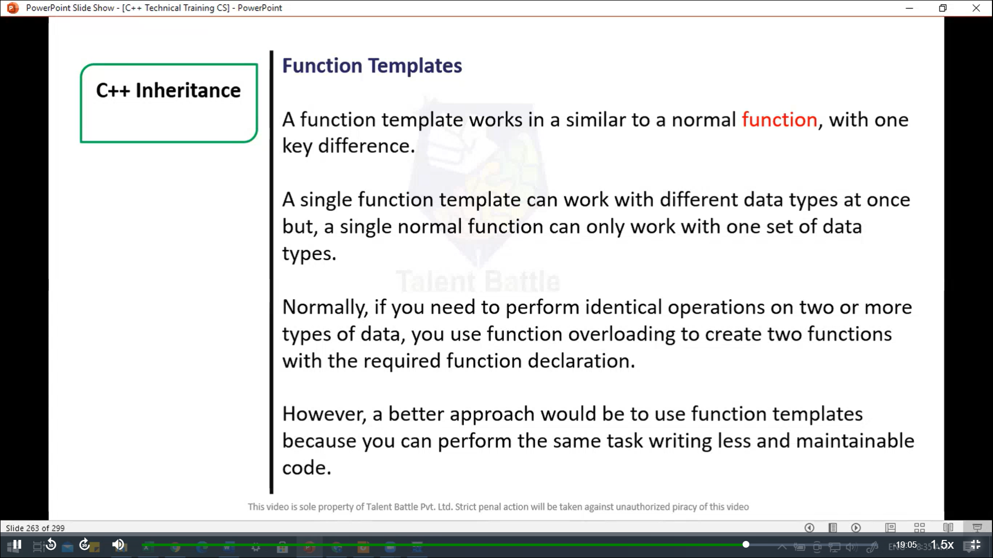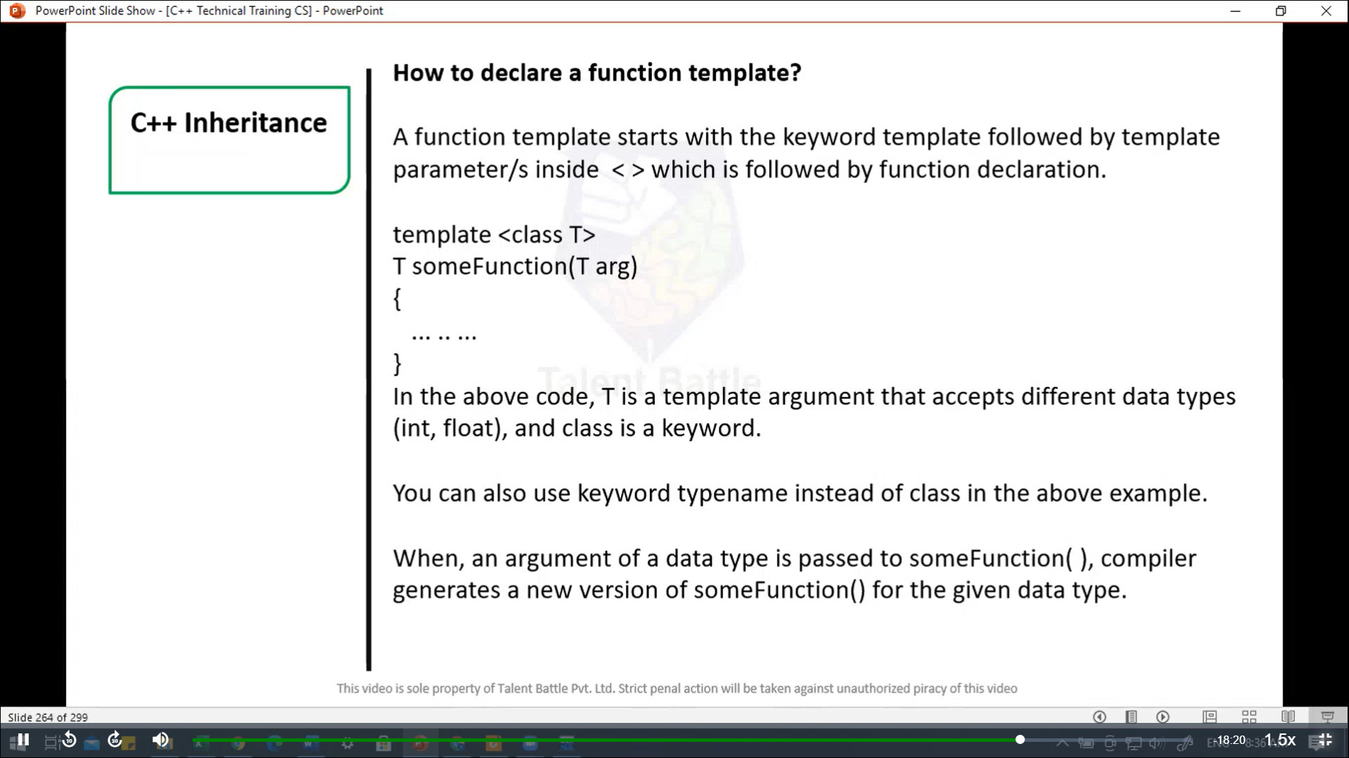

//=====================================================

// Program to display largest among two numbers using function templates.

// If two characters are passed to functon template, character with larger ASCII value is displayed

#include <iostream>

using namespace ***std***;

// template funciton

template <class T>

T *Large*(T ***n1,*** T ***n2***){

  return (***n1*** > ***n2***) ***?*** ***n1*** ***:*** ***n2***;

}

int *main*(){

  int i1***,*** i2;

  float f1***,*** f2;

  char c1***,*** c2;

  cout  *<<* "Enter two integers:**\n**";

  cin *>>* i1 *>>* i2;

  cout *<<* *Large*(i1***,*** i2) *<<* " is larger. " *<<* *endl*;

  cout *<<* "**\n** Enter two floating-point numbers:**\n**";

  cin *>>* f1 *>>* f2;

  cout *<<* *Large*(f1***,*** f2) *<<* "is larger." *<<* *endl*;

  cout *<<* "**\n**Enter two characters:**\n**";

  cin *>>* c1 *>>* c2;

  cout *<<* *Large*(c1***,*** c2) *<<* " has larger ASCII value.";

  return 0;

}

/*

Enter two integers:

55

66

66 is larger.

 Enter two floating-point numbers:

33

22

33is larger.

Enter two characters:

h

l

l has larger ASCII value.

--------------------------------

Process exited after 18.82 seconds with return value 0

Press any key to continue . . .

*/